* Download and install Eclipse 4.3.1 (<http://www.eclipse.org/downloads/>) and JDK (<http://www.oracle.com/technetwork/java/javase/downloads/index.html>)
* Run Eclipse and create a new Eclipse workspace

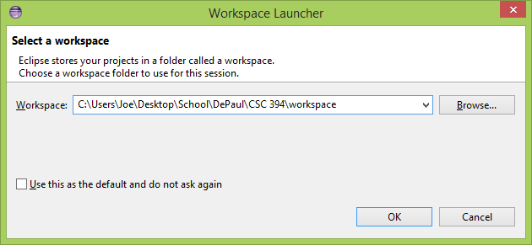

(the exact location doesn’t matter)

* Create a new Java Project called “Virtual Keyboard”

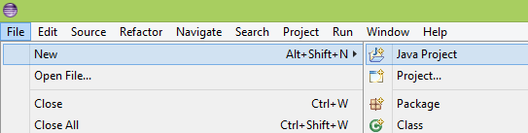

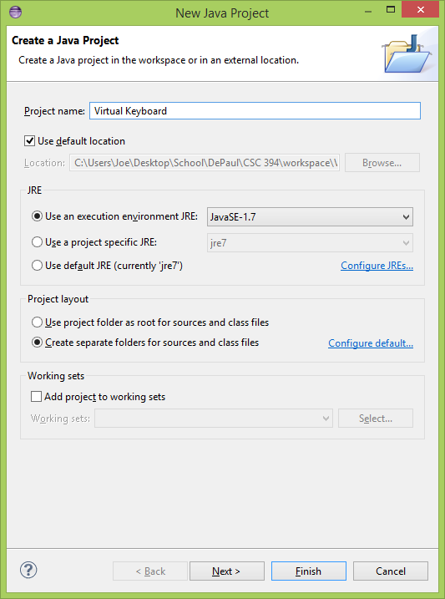

* Copy the files from the “Virtual Keyboard” folder in the most recent zip file into your workspace’s “Virtual Keyboard” folder

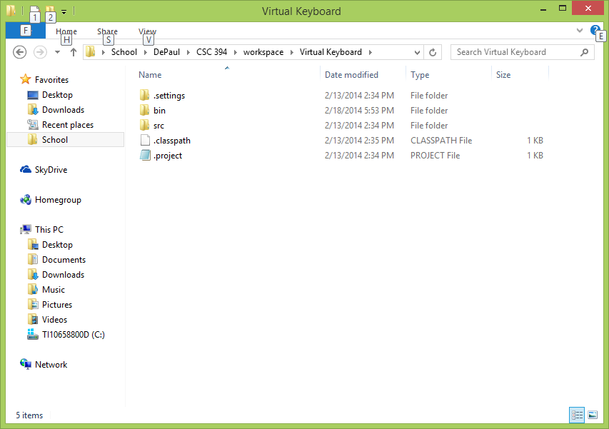

* In Eclipse, right click the project in the Package Explorer and select “Properties”

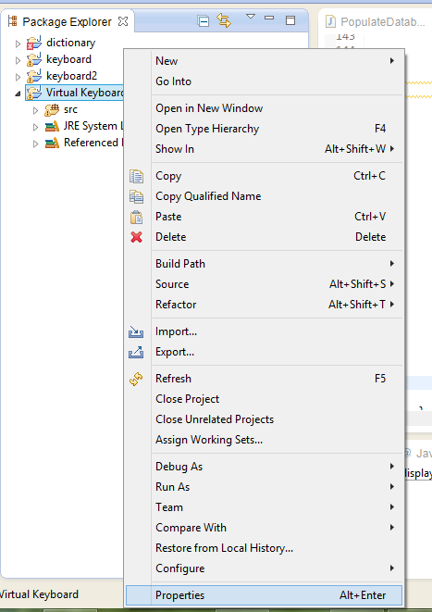

* Select “Java Build Path”, then click “Add External JARs”

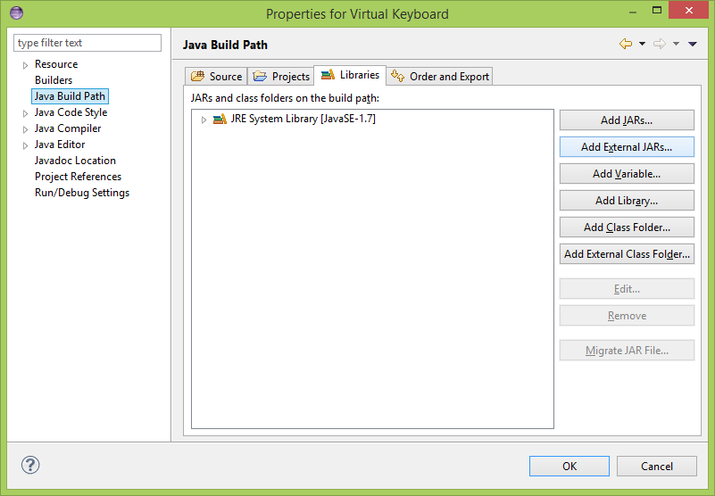

* Navigate to the “mysql-connector-java-5.1.27” folder included in the zip file, find

“mysql-connector-java-5.1.27-bin.jar” and click open

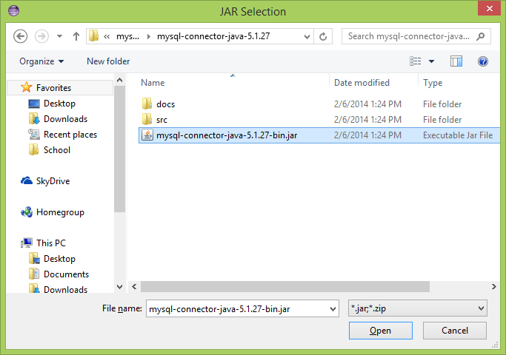

* Click the green run button to run the program

